BIT 4107-Mobile Application Development
ENHANCED PROFESSIONAL STUDENT LOGBOOK
Student name: SHARON KENDI
Admission Number: BIT/2024/ 57117
School/Faculty: COMPUTING AND INFORMATICS
Program me:
Academic Year: THREE
Semester: TWO
Lecturer: MICHAEL NYORO
Phone Number:0768444898

WEEK 1: INTRODUCTION TO MOBILE APPLICATION DEVELOPMENT
TOOLS AND SOFTWARE USED
Android Studio
VS Code
Flutter SDK
Dart
Android Phone

PERSONAL REFLECTION

Installing Android Studio, Flutter, and the SDK Manager was a valuable learning experience that required patience and problem-solving. Although I encountered challenges such as configuration issues and installation errors, I learned how to troubleshoot problems, use terminal commands, and manage software dependencies. Successfully setting up the development environment improved my technical skills and confidence, preparing me for mobile app development.

WEEK 2: MOBILE DEVELOPMENT ENVIRONMENT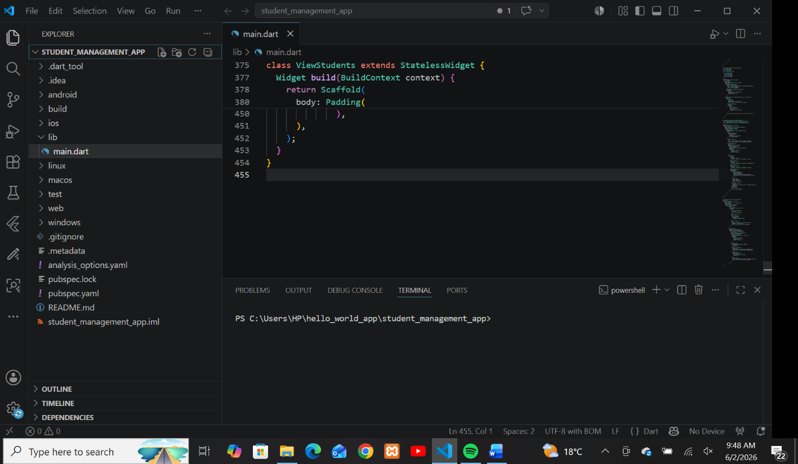
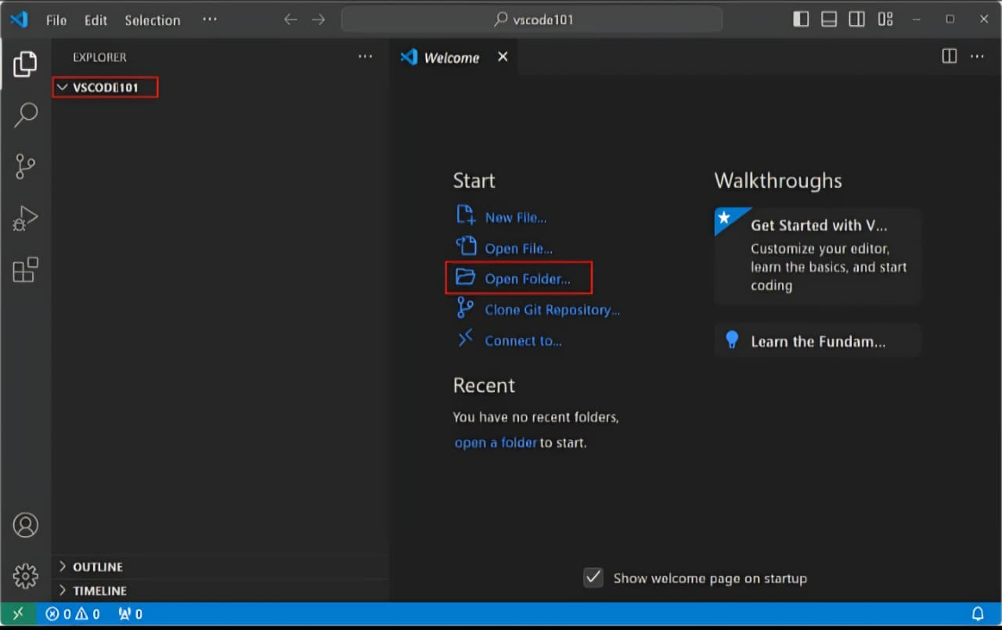

PERSONAL REFLECTIONS
Working with a mobile development environment was a valuable experience that helped me understand the tools and processes involved in app development. Setting up and configuring the environment required patience and attention to detail, especially when installing software, managing dependencies, and resolving errors. Through this experience, I improved my problem-solving and technical skills while gaining confidence in using development tools. Overall, the mobile development environment provided a strong foundation for creating, testing, and debugging mobile applications.

WEEK 3: USER INTERFACE DESIGN

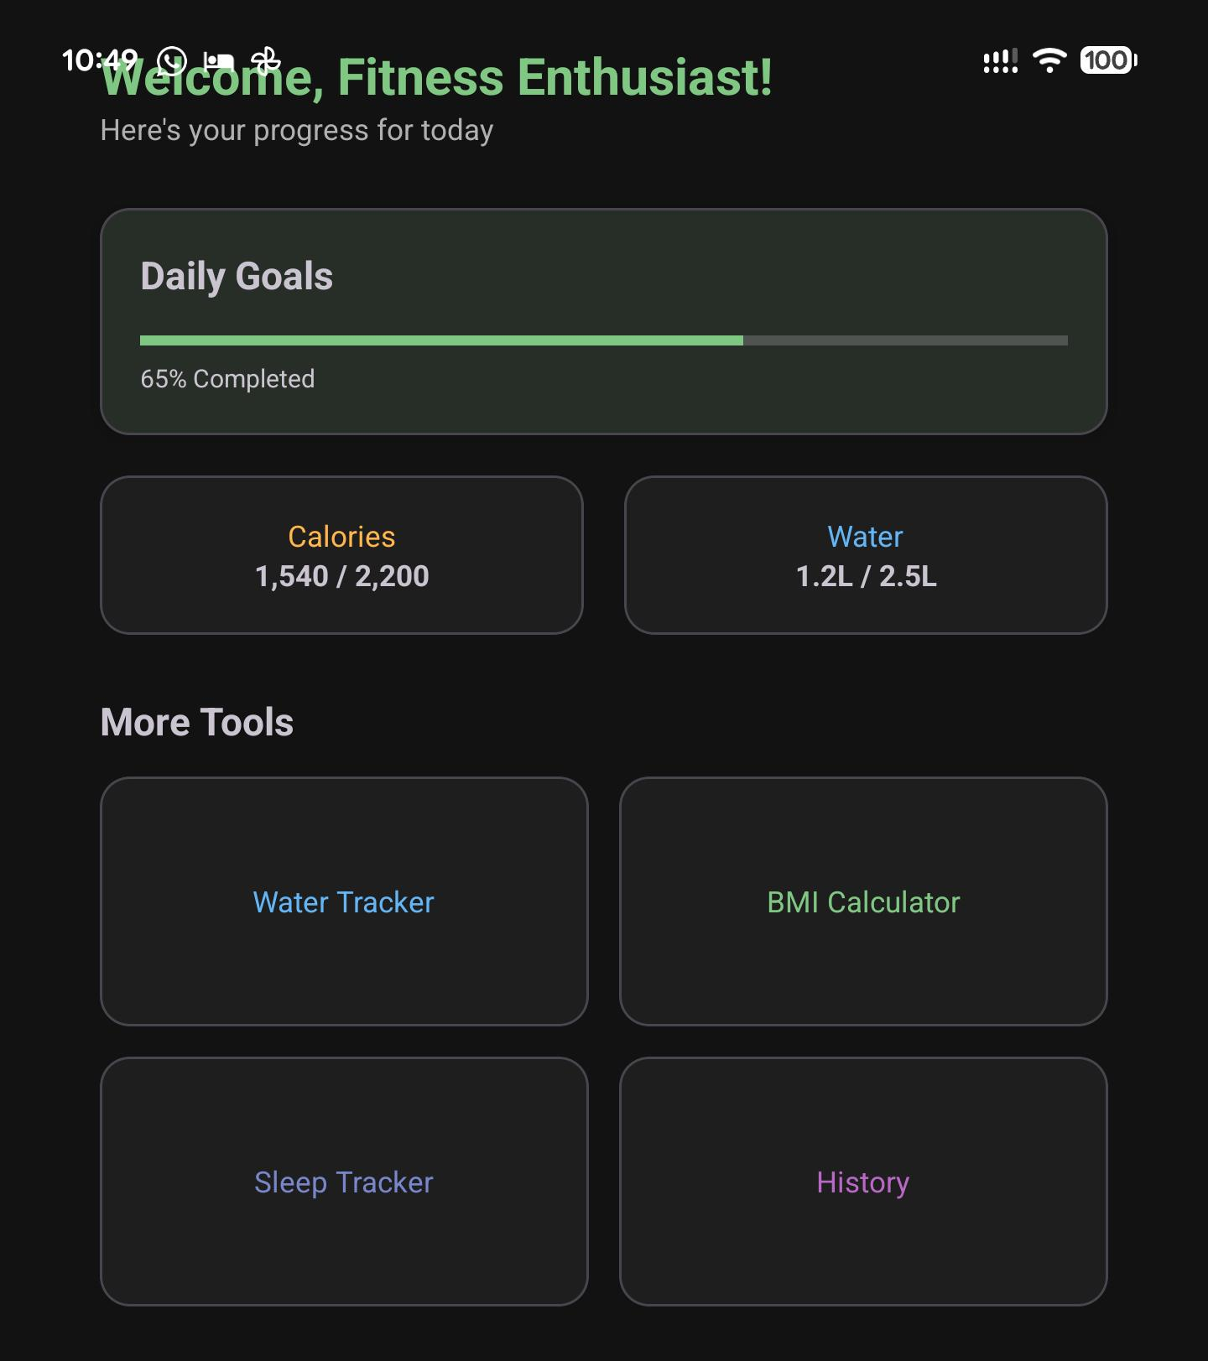
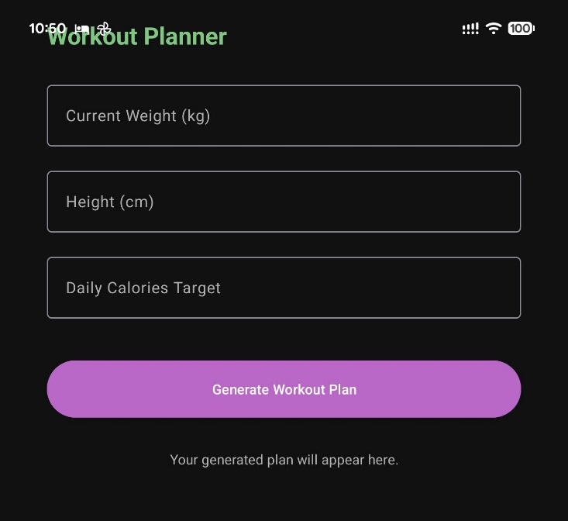
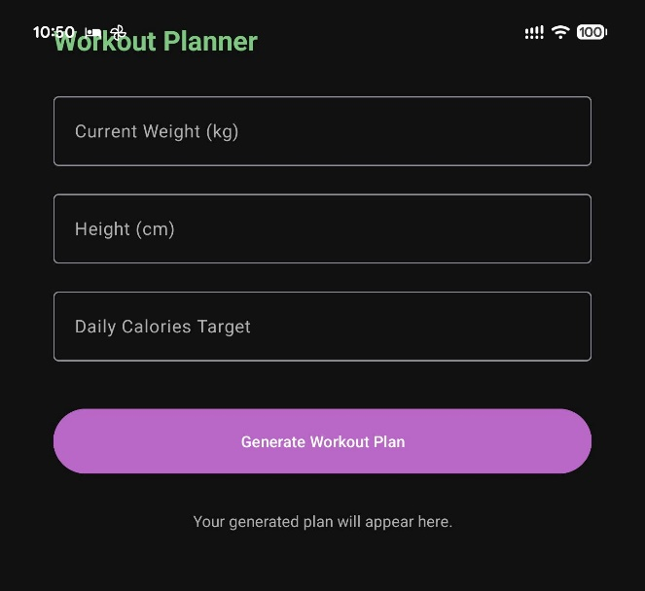
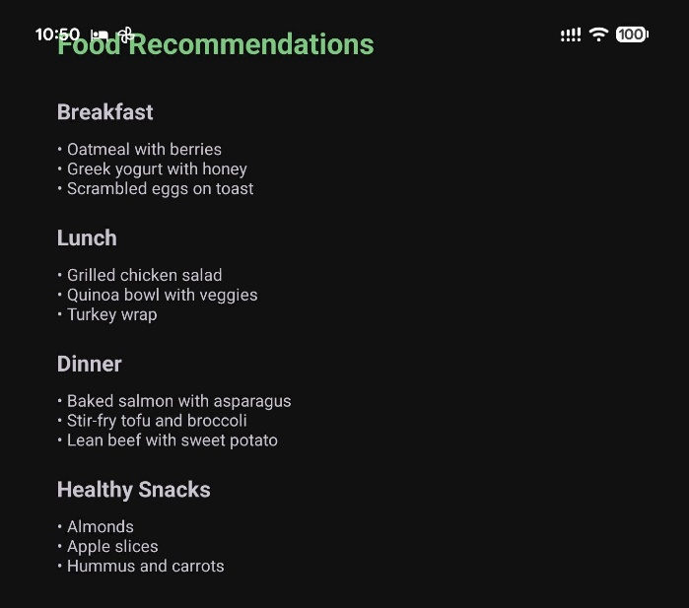
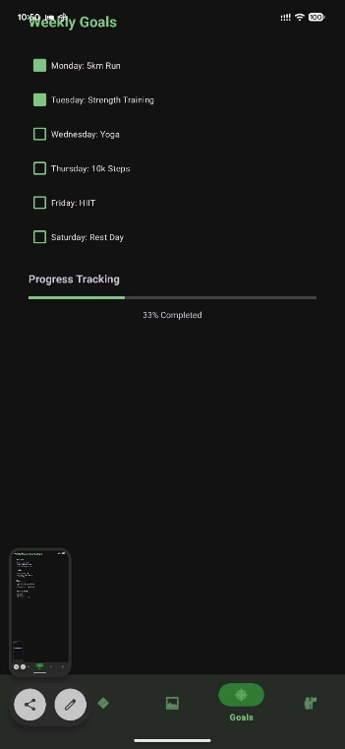
Personal reflection
Designing the fitness app user interface helped me understand the importance of creating a simple, attractive, and user-friendly design. I learned that effective UI design combines both visual appeal and functionality through the use of consistent layouts, appropriate colors, fonts, and icons. This experience improved my creativity, problem-solving abilities, and understanding of user-centered design principles, while highlighting the role of UI design in enhancing user satisfaction and application success.

Week 4: Event handling and user interaction
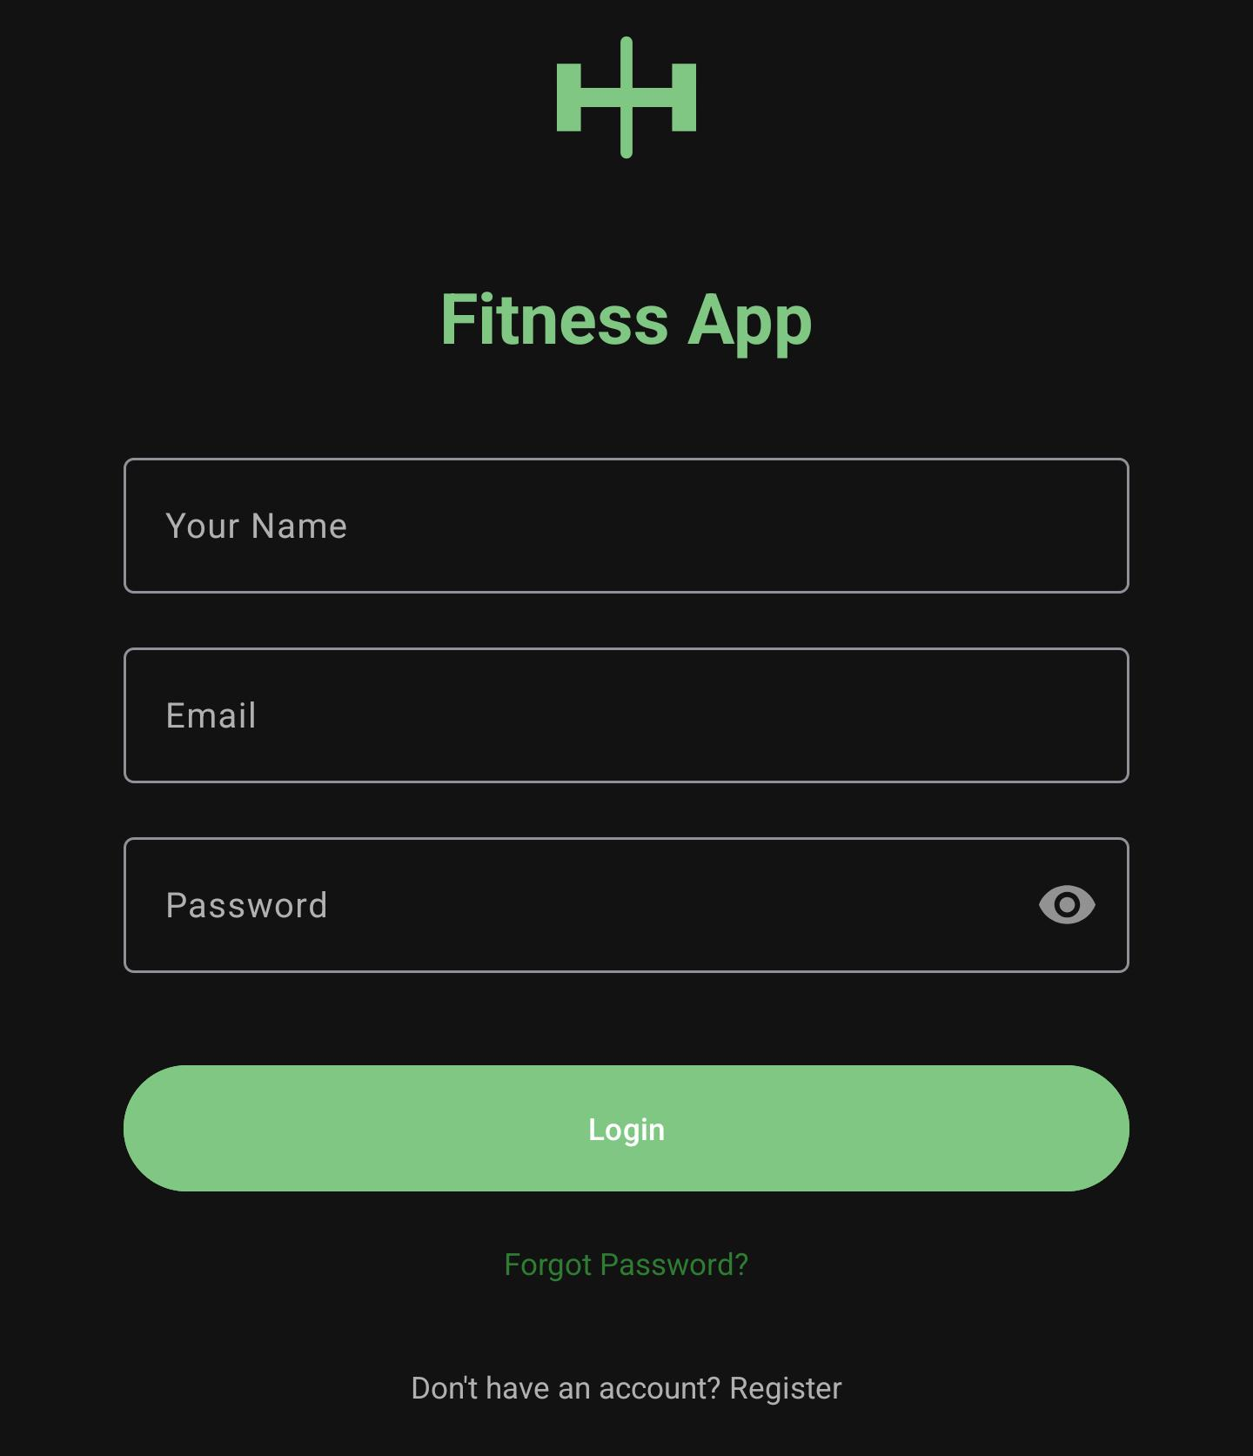
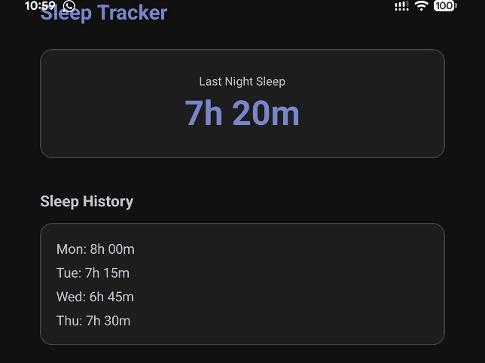

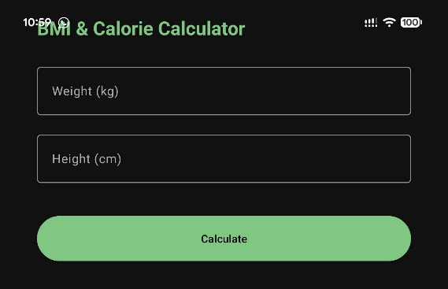
Personal reflection
Working on event handling and user interaction in the fitness app helped me understand how user actions trigger responses within the application. I learned the importance of creating responsive, intuitive, and user-friendly features that improve navigation and functionality. This experience strengthened my programming and problem-solving skills while highlighting the role of interactive features in enhancing the overall user experience.
Week 5: Data management
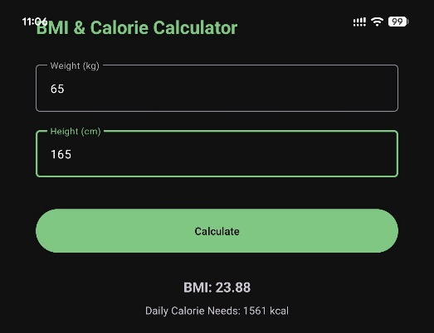
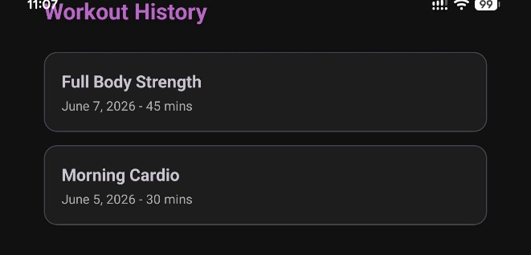
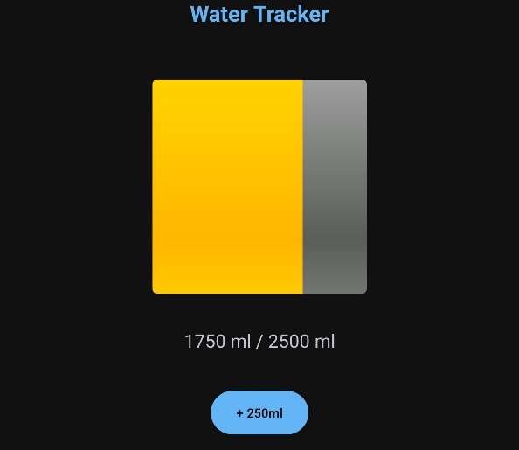
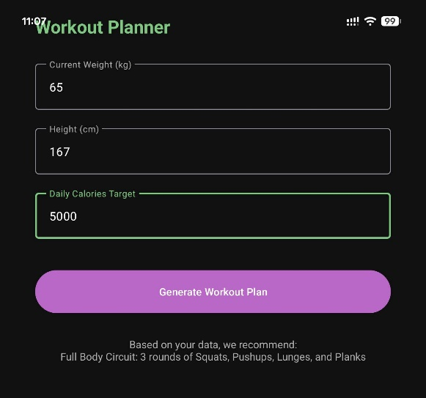
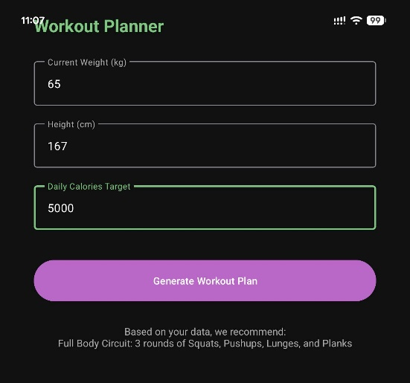
Personal reflection
Working on data management in the fitness app helped me understand the importance of storing, organizing, and retrieving user information efficiently. I learned how to manage data such as user profiles, workout records, fitness goals, and progress tracking to ensure accurate and reliable application performance. This experience showed me the value of maintaining data integrity and security while providing users with personalized and meaningful insights. Overall, developing data management features improved my technical skills and deepened my understanding of how effective data handling contributes to a functional and user-friendly fitness application.

Week 6: Networking and APIs

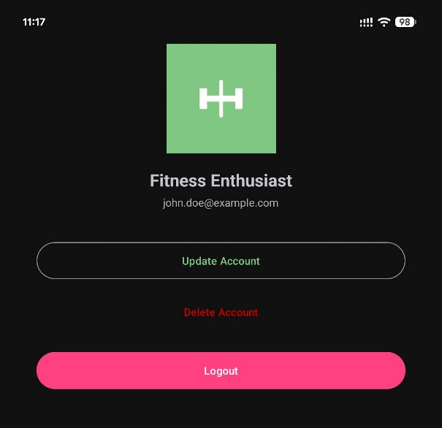

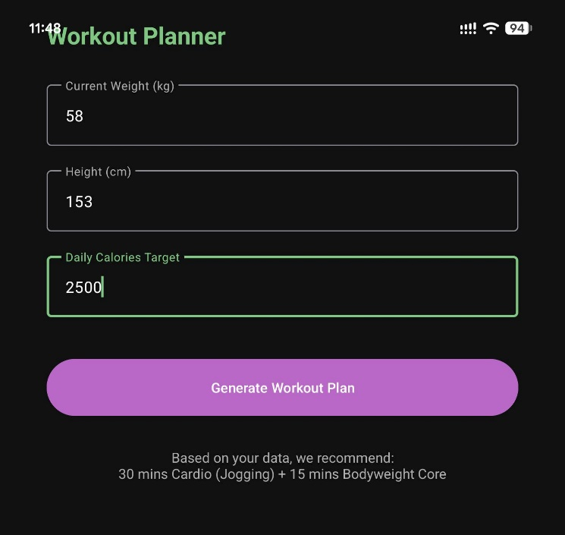
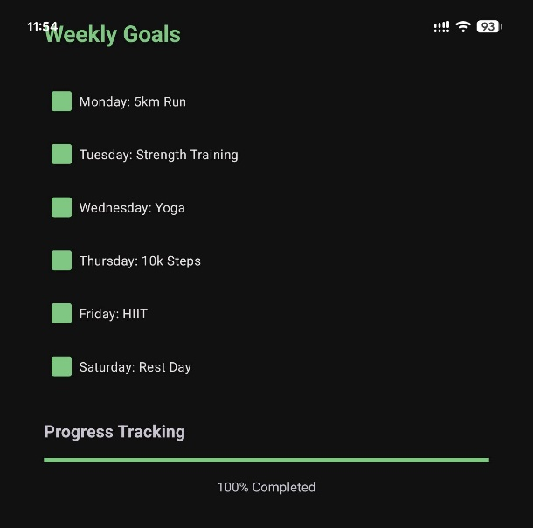

personal reflections
Working with networking and APIs in the fitness app helped me understand how applications communicate with external services to exchange data. I learned how APIs can be used to retrieve and update information such as workout plans, fitness statistics, user profiles, and health data. Implementing API connections improved my understanding of sending requests, handling responses, and managing data efficiently within the application.
This experience also taught me the importance of error handling, data security, and maintaining a stable internet connection to ensure a smooth user experience. Overall, working with networking and APIs enhanced my technical skills and gave me a better understanding of how modern mobile applications integrate with external systems to provide dynamic and personalized features.

Week 7: Application Architecture
